**To start the application, please follow the instruction in sequence:**

1. SQL script
2. Backend Server – Select either mysql or mongo db
3. React JS front end
4. SQL script
5. Under the source code folder, there is a database folder. Run the scripts in MYSQL workbench in sequence.

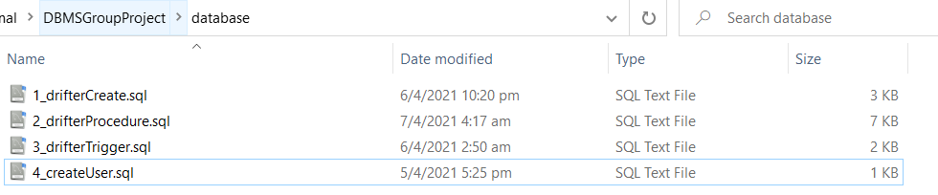

1. Node JS Server

2.1 MySQL

1. Under mySQL/config.js, change the sql credential as shown below

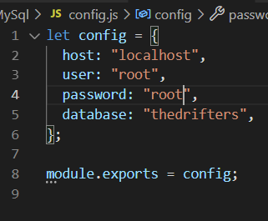

1. Under mysql/csvInsertMySql.py , change the sql credential as shown below

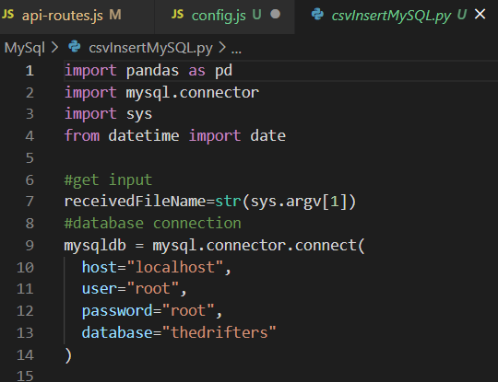

1. Type in the command cd mongodb to be redirected into the file, like shown in the photo below



1. Type npm install to install all the required library

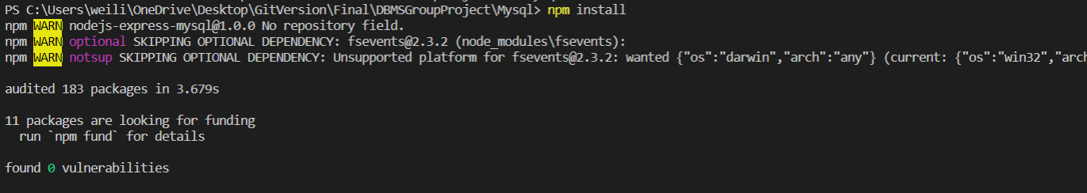

5. Type node server.js to start the server



2.2 MongoDB

1. Type in the command cd mongodb to be redirected into the file, like shown in the photo below



1. Type npm install to install all the required library



1. Type node index.js to start the server



1. React JS start guide

Steps:

1. After downloading the file open CMD
2. Type in the command cd react-frontend to be redirected into the file, like shown in the photo below



1. After entering the file type in the command npm install to install all required libraries, like shown in the photo below

1. After successfully installing all the libraries, in the CMD type in the command npm start to start up the whole program for the front end, like shown in the photo below



